# JIRA Configurations

## Story / Task / Bug statuses

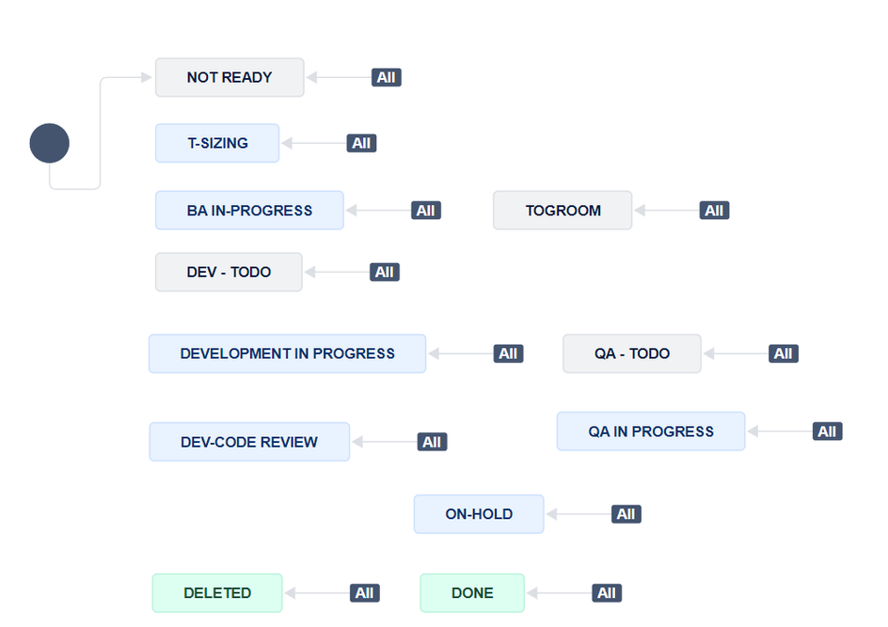

## Board workflows

We are not restricting transitions on board workflows. Any status can be transitioned to any status. This is to give enough autonomy to the team to get work done. At the same time, status changes are monitored through slack, regular calls and spot checks. These learnings are then taken into account, discussed and addressed in retros.

There are three types of workflows.

 BA & Lead workflow (Kanban)- all the work that happens external to the sprint.  Scrum workflow (Scrum) - all the work that happens inside a sprint.\

 External workflows. (Scrum / Kanban) - optional - workflows that happen with third-party companies.

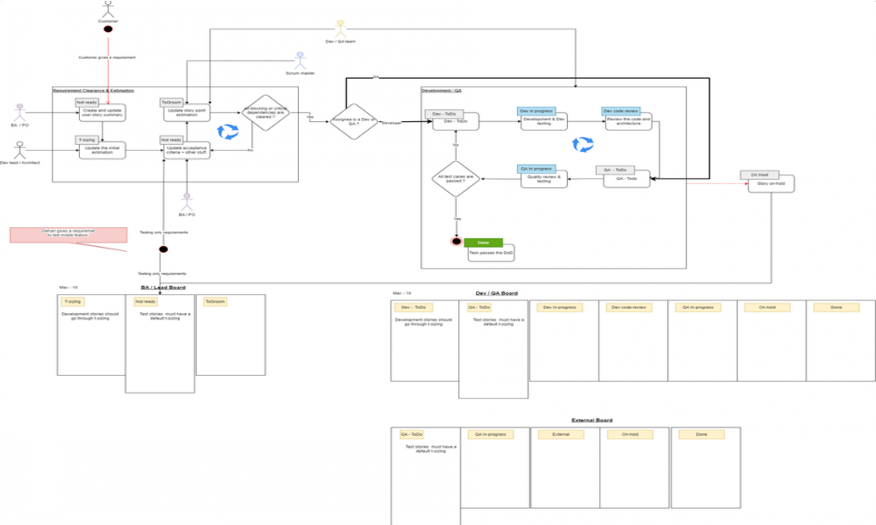

## Custom fields

Frontend Dev - A user selection field Backend Dev - A user selection field QA owner - A user selection field Hold/Delete reason - Selectable options  Options available

 Incomplete Requirements  Requirement Change

 Dependancies

 Require more R&D

 Regulatory & Compliance  External Disruptions

 Procurement Delays

 Personnel unavailability Held date - A Date field

Due date - A Date field

Estimated Dev Hours - A Time field Estimated QA Hours - A Time field Errors - A number field

## Custom filters

Team member wise filters (Considering Frontend / Backend / QA owner and Assignee fields) User story and bugs

## Automations

Import this file into your project for automation:

|  |  |
| --- | --- |
| 1 | [TP - Assign - Backend development to Thambara](https://inivos.atlassian.net/jira/settings/automation%23/rule/16231686) |
| 2 | [TP - Assign - Devops development to Dileepa](https://inivos.atlassian.net/jira/settings/automation%23/rule/16231687) |
| 3 | [TP - Assign - Mobile Frontend development to RIshi](https://inivos.atlassian.net/jira/settings/automation%23/rule/16231688) |
| 4 | [TP - Assign - Web Frontend development to SM](https://inivos.atlassian.net/jira/settings/automation%23/rule/16231689) |
| 5 | [TP - Daily - Due date & hold status check](https://inivos.atlassian.net/jira/settings/automation%23/rule/16231690) |
| 6 | [TP - Daily - Management pulse checks](https://inivos.atlassian.net/jira/settings/automation%23/rule/16231691) |
| 7 | [TP - Dev Review Assigning](https://inivos.atlassian.net/jira/settings/automation%23/rule/16231692) |
| 8 | [TP - Epic fix version update applies to all stories under the epic](https://inivos.atlassian.net/jira/settings/automation%23/rule/16231693) |
| 9 | [TP - Epic & Story default allocation is to BA](https://inivos.atlassian.net/jira/settings/automation%23/rule/16231694) |
| 10 | [TP - Issue status change -> clear due date](https://inivos.atlassian.net/jira/settings/automation%23/rule/16231695) |
| 11 | [TP - Mid-sprint acceptance criteria changes -> Send to Lead Review](https://inivos.atlassian.net/jira/settings/automation%23/rule/16231696) |
| 12 | [TP - On-Hold Issue Transitions Rule](https://inivos.atlassian.net/jira/settings/automation%23/rule/16231697) |
| 13 | [TP - On-hold status to other status transition](https://inivos.atlassian.net/jira/settings/automation%23/rule/16231698) |
| 14 | [TP - QA Assigning](https://inivos.atlassian.net/jira/settings/automation%23/rule/16231699) |
| 15 | [TP - Sprint started -> Sprint 0 checklist](https://inivos.atlassian.net/jira/settings/automation%23/rule/16231700) |
| 16 | [TP - Status transition to Delete -> Story point clearing](https://inivos.atlassian.net/jira/settings/automation%23/rule/16231701) |
| 17 | [TP - When all stories are completed → then close epic](https://inivos.atlassian.net/jira/settings/automation%23/rule/16231702) |
| 18 | [TP - When initial estimation is updated -> Move it to BA WIP](https://inivos.atlassian.net/jira/settings/automation%23/rule/16231703) |
| 19 | [TP - When issue is added to an epic -> Fetch and update the fix version of the issue from the epic](https://inivos.atlassian.net/jira/settings/automation%23/rule/16231704) |
| 20 | [TP - When moved to Dev in progress from Code review -> Assign it back to the original developer](https://inivos.atlassian.net/jira/settings/automation%23/rule/16231705) |
| 21 | [TP - When parent is QA in progress → move all sub-tasks to QA in progress](https://inivos.atlassian.net/jira/settings/automation%23/rule/16231706) |

## Backlog configs

Apply a filter to filter out stuff the development team shouldn’t focus on while the sprint is running. These items are captured under the status.

**NOT READY**

## JIRA - How to

This document explains a few rules we’ve setup when it comes to using Jira in your day-to-day work.

##### Due dates

Why due dates.?

 Helps you set clear goals for yourself and achieve them.

 Helps other team members working on the same task to plan their day.  Helps leads identify gaps in the flow of work and address it upfront.

 Helps us keep delivery timelines and project plan up-to date.

A few guidelines to follow on this.

The due dates are assignee’s responsibility. The due date you’ve mentioned in a work-item should reflect the reality. Not an overestimation or even an underestimation. Try to be as realistic as possible.

The expectation is that you’ll be able to complete the work from your side and transition it to another team member within EOD the date mentioned in the task.

 If not, you should update the date by EOD. This change should go with your daily update in the

**DAILY SCRUM**

Dates are checked every morning automatically. should verify this in the



**SM**

**DAILY SCRUM**

##### Comments

A few guidelines to follow on this.

Be polite and professional.

keep it crystal clear and on point. Avoid being vague. (eg:- “working on this”, “there are technical issues..”). We are a tech team - we speak the same lingo.

## Boards

## Scrum Board

Color codes

Quick filters

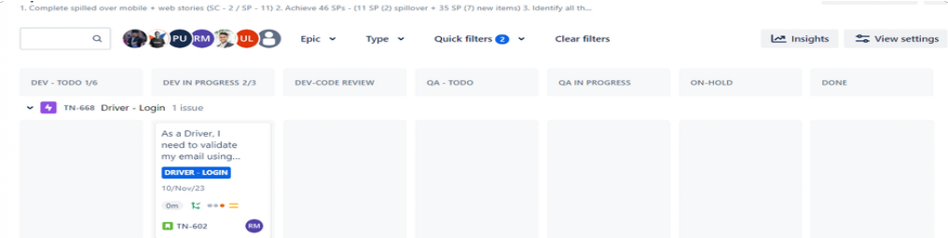

## BA & Lead board

Color codes

Filters

